**Front-end Test**You need to create a **responsive** page with the middle section of attached PSDs.  
**FYI:** Please see below screenshot. You need to develop highlighted Middle section of the page.  
  
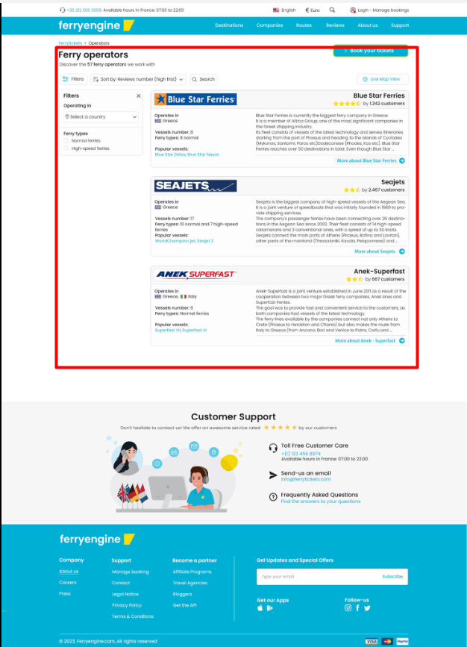  
  
Also, **please add the functionality to open/close the filter box only**. No need to add any other functionality such as sort, search etc.  
**Desktop version**: operators.psd  
**Mobile version**: operators-mobile.psd  
  
**Technology**: You need to use **Next.JS** to design the requested sections.  
  
**Note**: Please try to use boilerplate of next.js that have all the best practices in place that will help you to get better remarks.  
  
**Time Duration:** All you can do in **4 Hours**